- Aim:
To perform customer segmentation using K-Means clustering and visualize groups based on income and spending behavior using R.

- Scenario / Background:
- A retail store collects data about its customers including their annual income and spending habits.
The management wants to:
- Identify different types of customers based on purchasing behavior.
- Group customers into clusters for targeted marketing strategies.
- Understand high-value and low-value customer segments.
- Improve business decisions by analyzing customer patterns

Sample Dataset:

Customer ID | Income | Spending Score
1 | 15000 | 20
2 | 18000 | 25
3 | 25000 | 30
4 | 30000 | 35
5 | 45000 | 50
6 | 50000 | 55
7 | 65000 | 65
8 | 70000 | 70

R Program (with line-by-line comments):
# Create dataset (as given)
customer <- data.frame(
CustomerID = 1:8,
Income = c(15000, 18000, 25000, 30000, 45000, 50000, 65000, 70000),
Spending = c(20, 25, 30, 35, 50, 55, 65, 70)
)
# Display dataset
print(customer)
# Select required columns
data <- customer[, c("Income", "Spending")]
# Normalize the data
data_scaled <- scale(data)
# Apply K-Means clustering
set.seed(123)
kmeans_result <- kmeans(data_scaled, centers = 3)
# Add cluster labels to dataset
customer$Cluster <- kmeans_result$cluster
# Display result
print(customer)
# Plot clusters
plot(customer$Income, customer$Spending,
col = customer$Cluster,
pch = 19,
main = "Customer Segmentation using K-Means", xlab = "Income",
ylab = "Spending Score")
# Add cluster centers
centers <- kmeans_result$centers
centers_original <- t(apply(centers, 1, function(x)
x * attr(data_scaled, "scaled:scale") + attr(data_scaled, "scaled:center")))
points(centers_original,
col = 1:3,
pch = 8,
cex = 2)
# Add legend
legend("topleft",
legend = c("Cluster 1", "Cluster 2", "Cluster 3"),
col = 1:3,
pch = 19)

Output :
Customer ID Income Spending
1 15000 20
2 18000 25
3 25000 30
4 30000 35
5 45000 50
6 50000 55
7 65000 60
8 70000 70

Customer ID Income Spending Cluster
1 15000 20 3
2 18000 25 3
3 25000 30 3
4 30000 35 3
5 45000 50 1
6 50000 55 1
7 65000 65 2
8 70000 70 2

Graph:

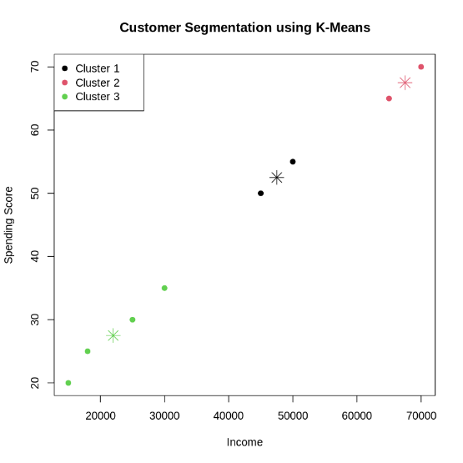
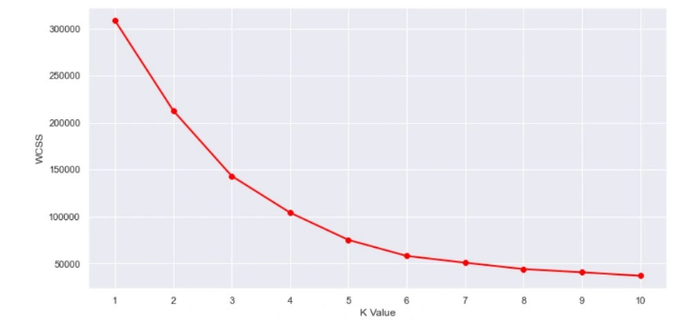

Overall Insight:
Clustering reveals distinct customer profiles that the business can use for strategy:
- High-Value Segment: High-income and high-spending customers (Cluster 2).
- Potential/Balanced Segment: Moderate income and spending (Cluster 1).
- Low-Value Segment: Low-income and low-spending customers (Cluster 3).
- Observation:
- The dataset shows clear variation in customer income and spending scores, indicating that customers behave differently despite similar earnings.
- Clustering reveals distinct customer segments such as:
- High-income, high-spending customers (premium or high-value customers)
- High-income, low-spending customers (potential customers who can be targeted to increase spending)
- Low-income, high-spending customers (impulsive or frequent buyers)
- Low-income, low-spending customers (low-value segment)
- Customers with similar purchasing behavior are grouped together, making it easier to understand patterns and preferences.
- The clustering helps identify target groups for marketing campaigns, allowing personalized offers and promotions.
- High-value customers can be prioritized for loyalty programs, while low-value customers can be targeted with strategies to improve engagement.

Submitted by:
Name: K.NARESH
Reg No: 11249A150
CSE, II Year & IV Sem

Topic: Mini Project Report on Customer Segmentation using K-Means Clustering
Data Science Using R Programming Lab

